INSERTING RECORDS IN DATABASE

mysql> INSERT INTO Venue (venue_id, venue_name, address) VALUES

-> (1, 'Shree Ram Theatre', 'Bhopal'),

-> (2, 'Bhopal Haat', 'Bhopal'),

-> (3, 'Vidisha Heritage', 'Vidisha'),

-> (4, 'Kamal Palace', 'Bhopal'),

-> (5, 'Shankar Temple', 'Vidisha');

Query OK, 5 rows affected (0.02 sec)

Records: 5 Duplicates: 0 Warnings: 0

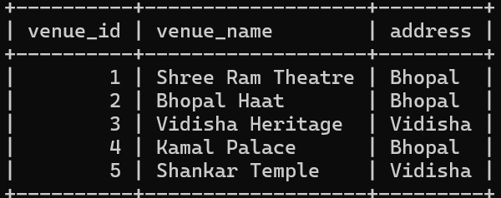

mysql> INSERT INTO Event (event_id, event_name, event_date, event_time, venue_id, total_seats, available_seats, ticket_price, event_type) VALUES

-> (1, 'Movie Night', '2024-10-10', '19:00:00', 1, 200, 150, 500.00, 'Movie'),

-> (2, 'Cricket Match', '2024-10-15', '16:00:00', 2, 5000, 4000, 1500.00, 'Sports'),

-> (3, 'Music Evening', '2024-11-01', '20:00:00', 3, 100, 80, 300.00, 'Concert'),

-> (4, 'Bhopal Carnival', '2024-10-20', '18:00:00', 4, 1000, 800, 700.00, 'Concert');

Query OK, 4 rows affected (0.02 sec)

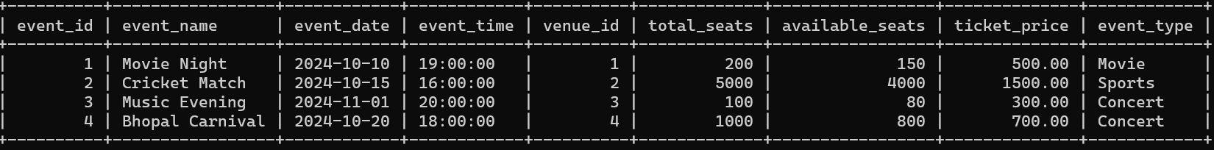Records: 4 Duplicates: 0 Warnings:

mysql> INSERT INTO Booking (booking_id, customer_id, event_id, num_tickets, total_cost, booking_date) VALUES

-> (1, 1, 1, 2, 1000.00, '2024-10-01'),

-> (2, 2, 2, 5, 7500.00, '2024-10-02'),

-> (3, 3, 3, 1, 300.00, '2024-10-03'),

-> (4, 4, 4, 3, 2100.00, '2024-10-04');

Query OK, 4 rows affected (0.01 sec)

Records: 4 Duplicates: 0 Warnings: 0

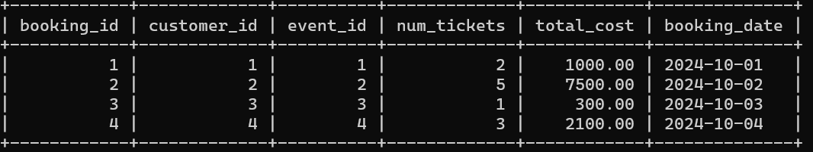

mysql> INSERT INTO Customer (customer_id, customer_name, email, phone_number, booking_id) VALUES

-> (1, 'Aditi Mishra', 'aditi.mishra@example.com', '7896543210', 1),

-> (2, 'Rohan Verma', 'rohan.verma@example.com', '7896543211', 2),

-> (3, 'Neha Pandey', 'neha.pandey@example.com', '7896543212', 3),

-> (4, 'Vikrant Shukla', 'vikrant.shukla@example.com', '7896543213', 4);

